
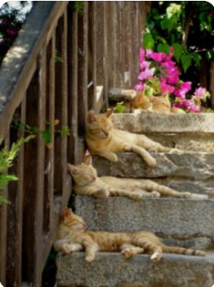
CATZ INC official entry forM

(Please use a separate entry form for each entry)
Show | The lazy Cat Show | Date | 31st August 2025

Sex | PATTERN | Breed Name | Colour | Cat / Kitten  Neuter / Spay  NB  Preliminary New Breed  PART PED HHP  COMPANION | Date of Birth | Office
Please select Category NOTE: Companions, Household Pets & NBC, coat length LH or SH

Cats Name: |  | Registration No:
Sire: |  | Colour:
Dam: |  | Colour:

Owners Name:
Address: |  | Phone No:
Address: |  | Fax No:
Owners Registered Prefix (If Any) |  | Email:
Breeders Name:
Breeders Address:

Please ensure the form is clear and easily read to help the entry clerk.

Entry Fees | $60.00 | Total Fees
Number of entries All entries  Cage Hire: $5.00 per cage *No of Cages required:  Benching Fees: ($5.00) pay once Only  Prepaid Catalogue: ($5.00)  Extra Cage Space $5.00  Please indicate if you are bringing a double sturdi cage for only 1 cat  Fill in all payments on first entry  TOTAL FEES PAYABLE HERE: |  | Entries $  Cages $  Benching $5.00  Catalogue $
 |  | $
PLESE INDICATE METHOD OF PAYMENT
I authorize my VISA / MASTERCARD to be charged with the above TOTAL. Yes/No
(My Credit Card details are on File)
I will pay Direct to Bank {This must be done within 5 days of entry being received} Yes/No
(Catz Inc Bank Account 12 3136 0024320 00
I/We consent to uphold to the Constitution, Registration and Show Rules of CATZ (Inc) as amended from time to time. Yes/No

Signed: | Date:
If required, a copy of the CATZ (Inc) Show Rules may be obtained from the General Secretary upon payment of a fee or downloaded from http://catzinc.org A copy will be available for viewing at the Show.
PUBLICATION OF INFORMATION & PRIVACY: PLESE INDICATE WHICH OF THESE YOU AGREE TO:
I/We agree to our Name/Phone/Prefix/Email being printed in the Show Catalogue. YES / NO
I/We agree to our Name/Breed/ Prefix/Phone/Email being printed on public handouts. YES / NO

